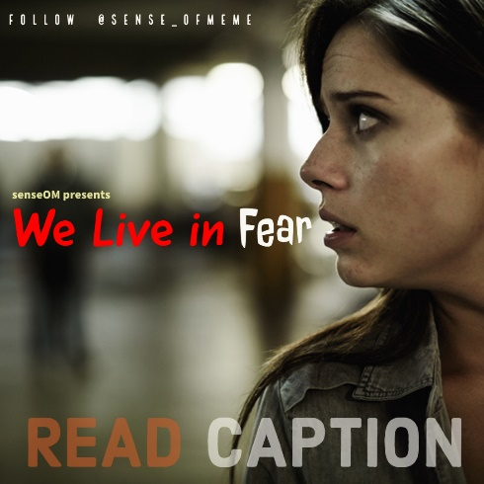

For countless women, there aren’t many things in everyday life scarier than walking home alone at night. Fear of the dark and the evil that lurks there is built into them from the moment they become conscious of what it means to be a woman. “Night” is synonymous with violence, assault, crimes that go undetected.  
  
Women have different Experiences in public places than do men, particularly when they are alone. Recently, I came around a story where a boy wrote that he and his friend were walking to a 24/7 department store and they saw a girl carrying trolley bag way back to her home. When that girl noticed these boys, she got panicked and started walking faster with her face down. This might be the Fear she felt from them. So is this acceptable?  
  
If you are a man, you are part of rape culture. I know, that sounds rough. You’re not a rapist, necessarily. You may think it’s unfair that we have to counteract and adjust ourselves for the ill behavior of other men. You know what? You’re right. It is unfair. Is that the fault of women? Or is it the fault of the men who act terrible and make the rest of us look bad?  
  
That’s why I think I should go out of my way to use clear body language and act in a way that helps minimize a woman’s fear and any related feelings. I recommend you do the same. It’s seriously, like, the least any man can do in public to make women feel more comfortable in the world we share. Just be considerate of her and her space.  
  
If women can’t trust and accurately assess the intentions of men she knows, how can you expect her to ever feel that she can accurately assess you, a stranger? Rape prevention is not just about women teaching women how not to get raped — it’s about men not committing rape.  
  
Women are not weak, but we are seen as prey to some people in the world. Please take action and protect yourself and those around you. Just be the change. Share this post as much as you can and let's build a chain to Support Women Get Over with this Fear. Don't Break the Chain and let Women know that they are not alone and we as a Society are with them.  
  
Don’t limit yourself to being a man. Be a human being.  
----------------------  
Writer : [@sense_ofmeme](https://www.instagram.com/sense_ofmeme/)